**Creating a Blender Model From an IMOD Model**

**Objective:** Convert IMOD’s mod file into a Reconstruct series for import into CellBlender.

**Necessary Tools**:

* Mac OS
* IMOD <https://bio3d.colorado.edu/imod/download.html>
* imod2reconstruct_macosx <https://cnl.salk.edu/~bartol/mitochondria/>
* CellBlender with Neuropil Tools (Cannot Run on Windows) <http://www.cnl.salk.edu/~bartol/cellblender_bundle/>

**Before Beginning:**

* Approve all interpolated contours so that there are no dotted lines left in your series.
* Give every object a name by selecting its number in the information window and going to .Edit > Object > Type… .
* Change the pixel size to “0.00164 um” by going to .Edit > Model > Header.
* Make sure you have saved your IMOD model file with the .mod prefix. (Example: mito1.mod) This can be done through File > Save As.

**Creating a Reconstruct Series from an IMOD Model using a Terminal Window:**

* After downloading imod2reconstruct_macosx, move it into your bin directory using a terminal window.
  + *If you need to create a bin directory, you can create one in the command line. Open a terminal window and use the “cd” command to move to your home directory. (Example:* ***cd /Users/[YourUsername]****) Once there, use the”mkdir” command to make a bin directory. (Example:* ***mkdir bin****)*
  + Use the “mv” command to move imod2reconstruct_macosx into your bin directory. (Example: **mv imod2reconstruct_macosx ~/bin**)
* Change permissions on the imod2reconstruct_macosx file so that you can run it.
  + Use the “cd” command to enter your bin directory. (Example: **cd bin**) You can see if you successfully moved imod2reconstruct_macosx there by entering “ls”. This will show you a list of everything in your current directory.
  + Enter **chmod a+x imod2reconstruct_macosx** to allow your computer to run this program. (Note: If the imod2reconstruct_macosx file has been given the name imod2reconstruct_macosx.dms, you will need to include the .dms ending in your command; **chmod a+x imod2reconstruct_macosx.dms** .)
* Convert your IMOD .mod file to a .amod file.
  + Use the “cd” command to navigate to the directory to want to save your Reconstruct series in. This will be the file you want to open in CellBlender later. (Example: **cd ~/mitochondriaproject**)
  + Enter **imodinfo -a** [File_Name]**.mod >** [File_Name]**.amod** to create the .amod file.
* Create a subdirectory for your new Reconstruct series. (A file will be created for each section in your image stack, so you will want this folder to keep those files together.)
  + In the directory you want your Reconstruct series in, create a subdirectory with the “mkdir” command. (Example: **mkdir reconstructser**)
* Use the imod2reconstruct_macosx file to convert your .amod file into a .ser file.
  + Enter **~/bin/imod2reconstruct_macosx [file_name].amod reconstructser/reconstructser**. The “reconstructser” before the slash is the directory you are creating the new series in, while the “reconstructser” after the slash is the file name that will be given to the Reconstruct files.
  + Your Reconstruct series should now be ready to open in CellBlender. You can confirm this by entering **cd reconstructser** and then entering **ls**. You should see one file called reconstruct.ser and many files with numbers at the end to mark each section.

**Creating a 3D Model from a Reconstruct Series in CellBlender’s Neuropil Tools:**

* *As you go through this portion of the protocol, remember to save frequently.*
* Open CellBlender from the terminal window by entering **~/bin/my_blender**.
  + If there are objects in the center window (see below for examples), select them by pressing “a” and delete them by pressing “x”, then clicking on the Delete button that pops up on the screen.

|  |  |
| --- | --- |
| Objects | No Objects |
|  |  |

* Open the Reconstruct series file in Neuropil Tools
  + Open the “Neuropil” tab (see the yellow arrow in the image below) and expand the “3DEM Processor Tool” (red arrow).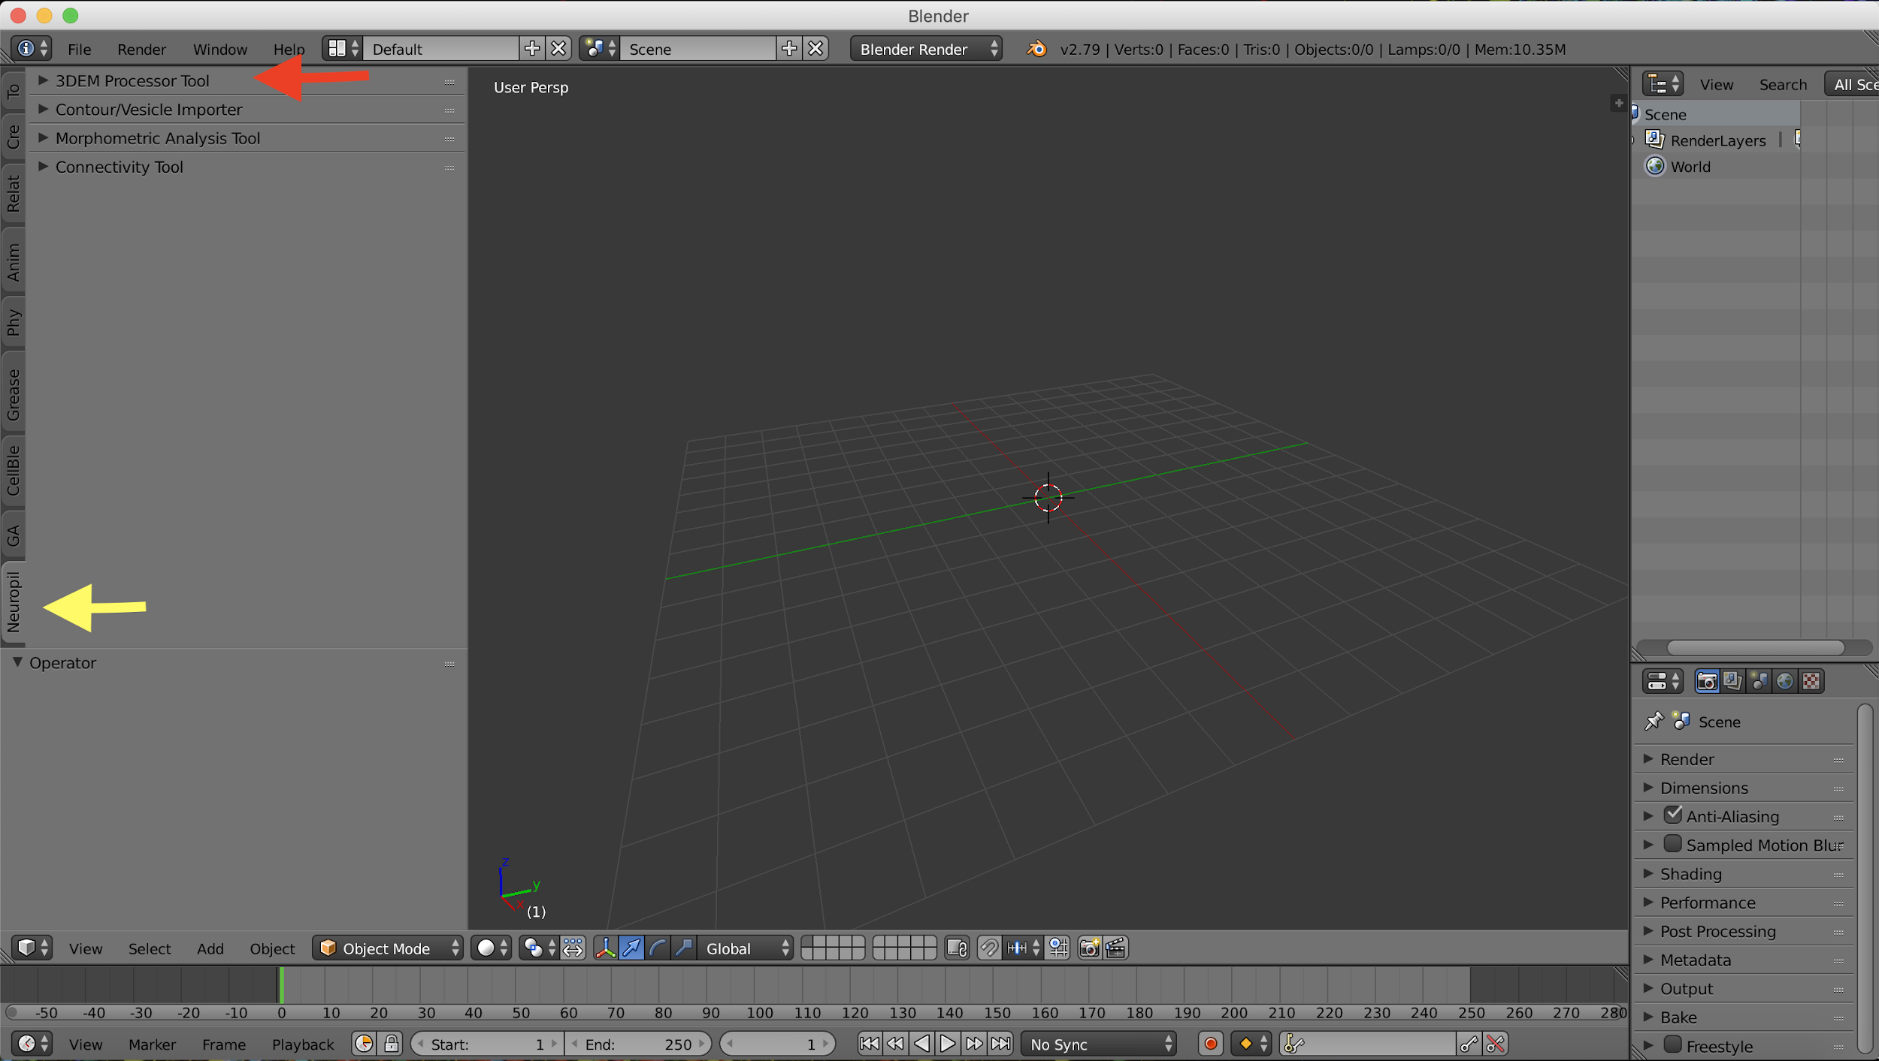
  + Select the .ser file by clicking on the file icon under “Import Reconstruct Series:” and navigating to the desired location in your file system.
  + After double-clicking on the .ser file, you should see the file listed under “Import Reconstruct Series:”. Below this text box, you should also see the section thickness (make sure this number is 0.00164, otherwise you will need to start again from the “Before You Begin” section of these instructions and enter 0.00164 um as the pixel size in IMOD) and min section/max section (these tell you what section numbers contain traces visible to Neuropil Tools).
  + Enter 0.003 into the Min Sample Interval Box.
  + In the Trace List box, you should see a list of all the trace objects you created in IMOD. Select an object in this list and press the arrow icon to move each object to the Include List. Repeat this until all of the objects you want to model are in the Include List.
  + Select an object in the Include List and click the center icon in the rightmost toolbox (see below) to generate a mesh for that object. Repeat until you have modeled all of the desired objects. Each object will take a few minutes to mesh.

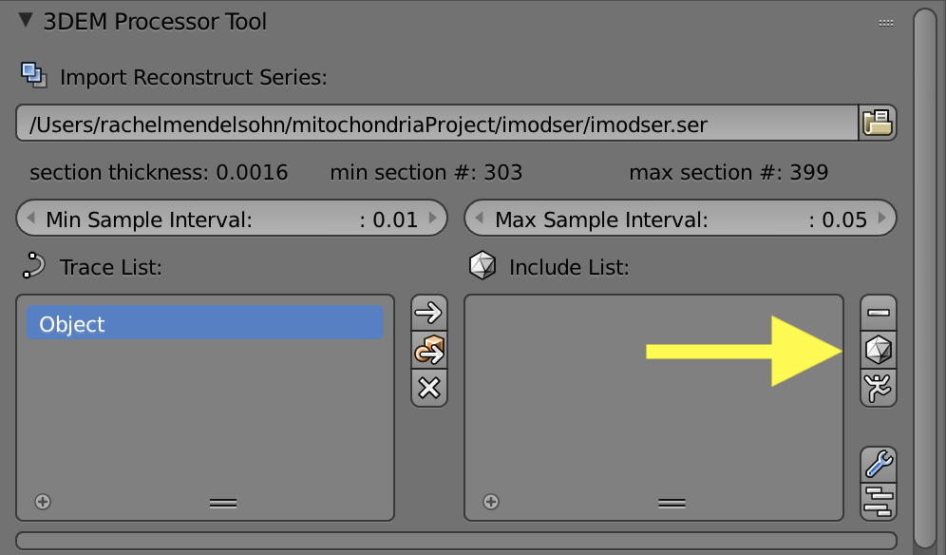

**Preparing for Mesh Improvement**

* You should now see each of your objects listed in the right-hand window (see below). Make a copy of each of these objects tiled [object_name]_raw by selecting the object in the list, moving the cursor into the 3D Viewer, and pressing Cmd-D. You can rename the object by right-clicking on it in the object list and pressing “Rename”.

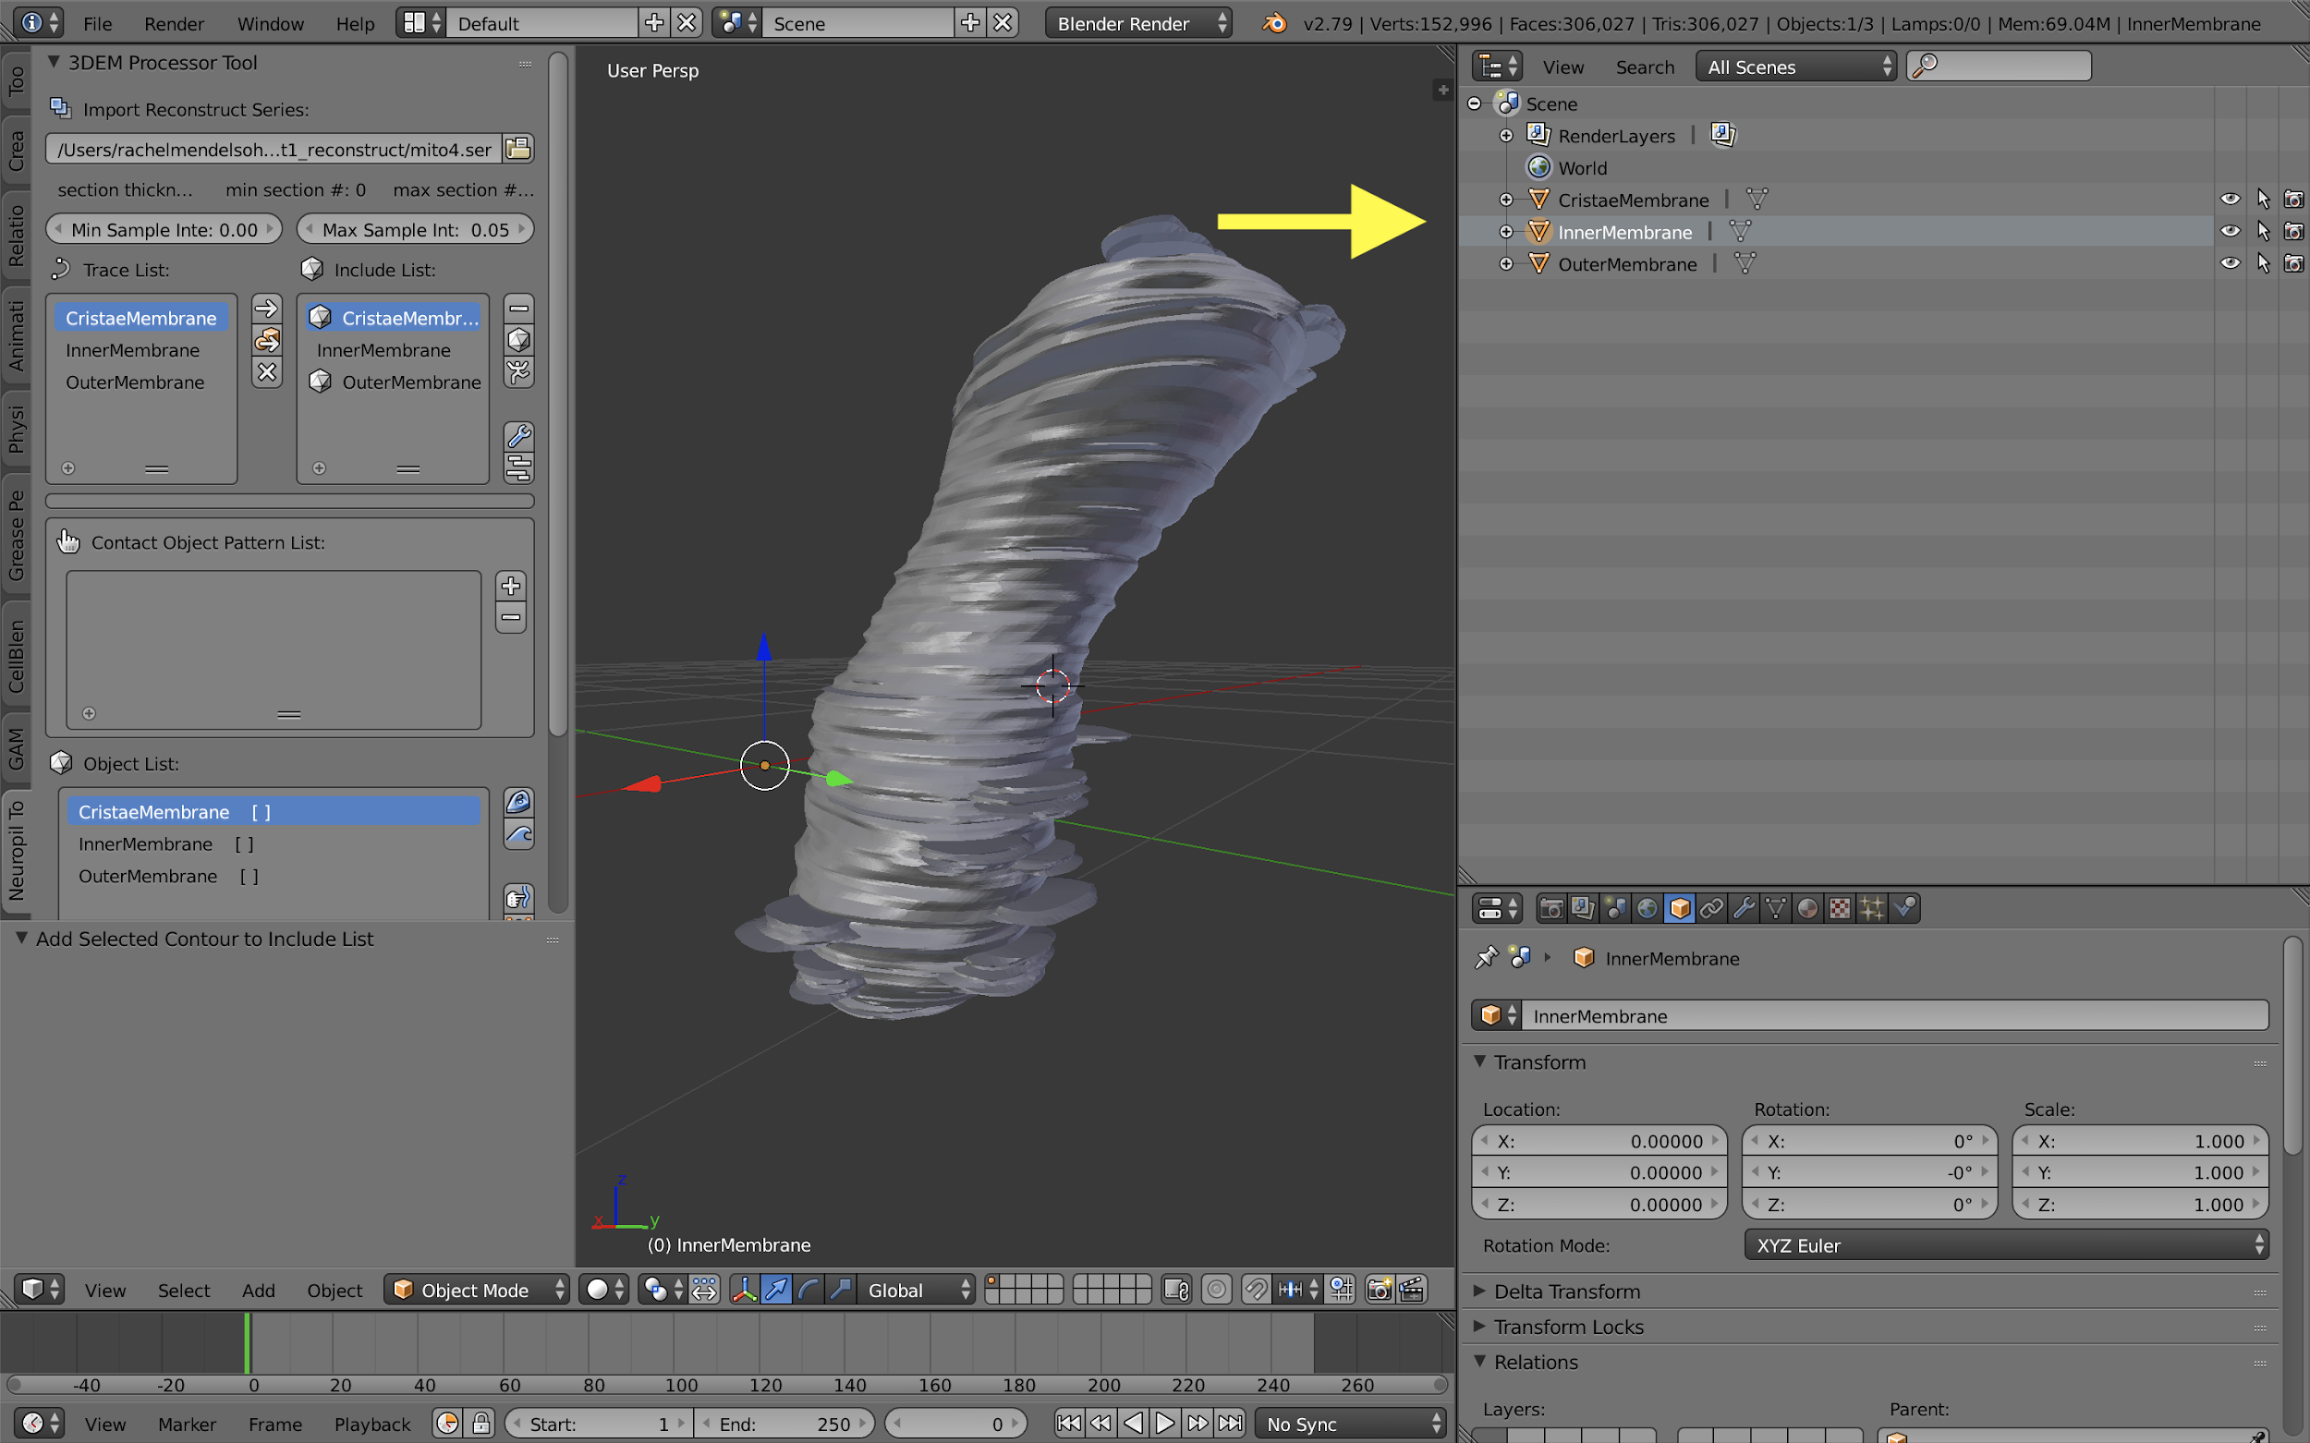

* Open the “GAMer” tab on the left (it may appear as “GA”) and click on the “Surface Mesh Improvement” button. These tools can be used to smooth the meshes in your model. See Chris or Tom for more information.

Unfortunately I have to get going. What an exciting conversation! Have a great day, everyone!